Aniket Thorat.

**Pratical - CICD Multibranch pipeline**

STEP 1- Create repository in git-hub mfusion-ms2.Create microservice from spring initializer



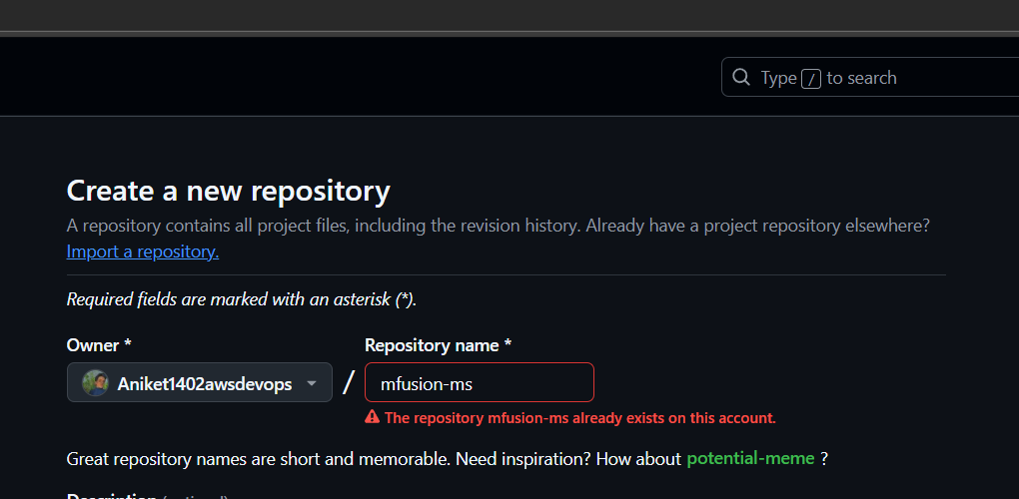

STEP 2 - Create microservice from spring initializer and name as your project mfusion-ms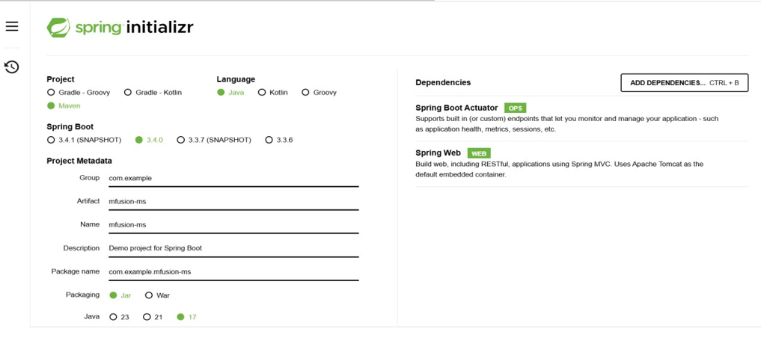

STEP 3 - Extract project into c:/myproject/ 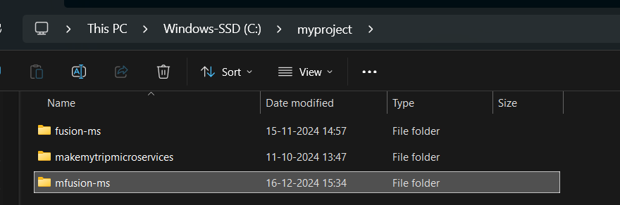

STEP 4 – Now open this project , create new files and folder and enable git , and git hub to push our code from local to remote 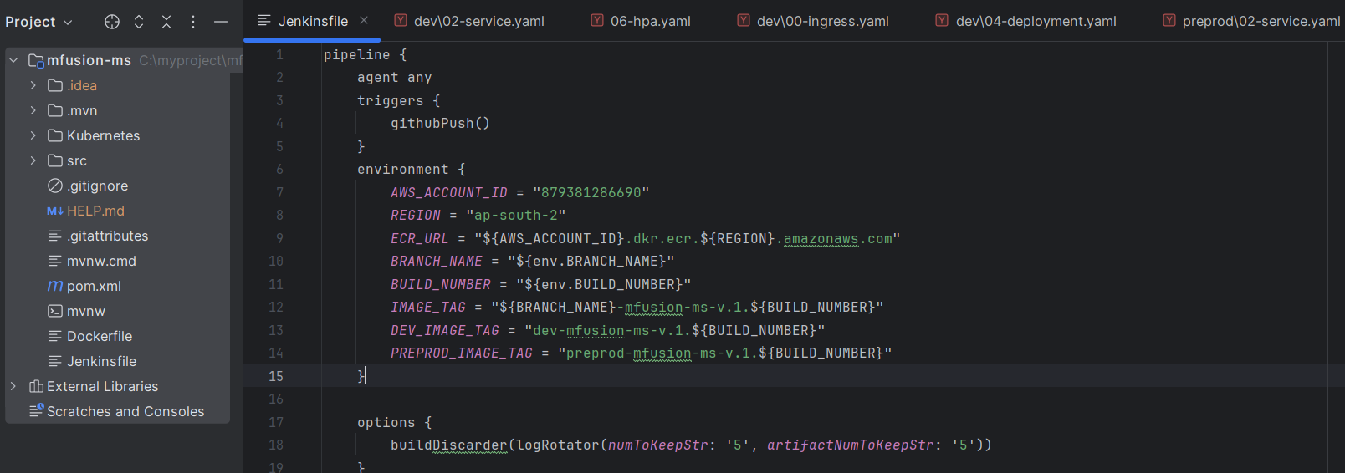

STEP 5 – Create a ec2 instance to and install all the required applications for CI-CD 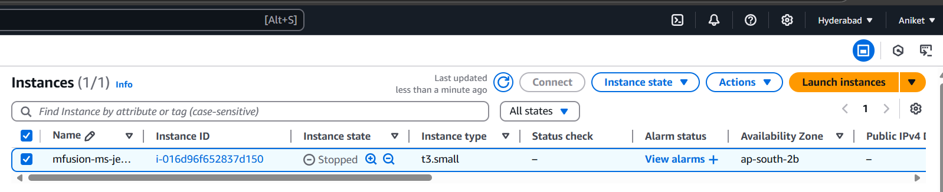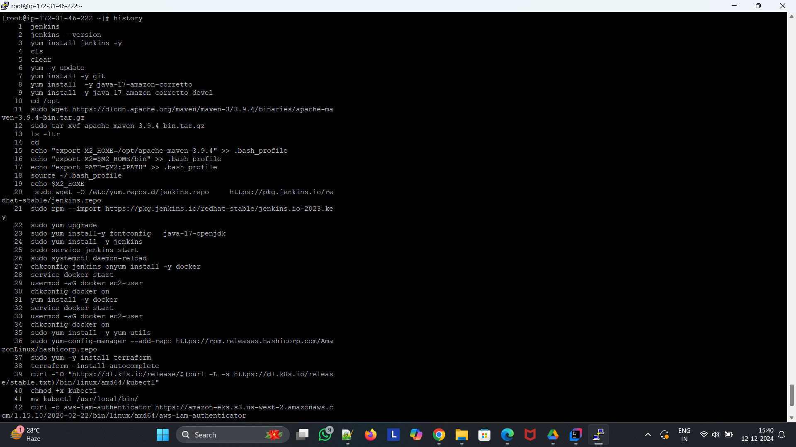

STEP 6- #add jenkins to root user , open vsudo

jenkins ALL=(ALL) NOPASSWD: ALL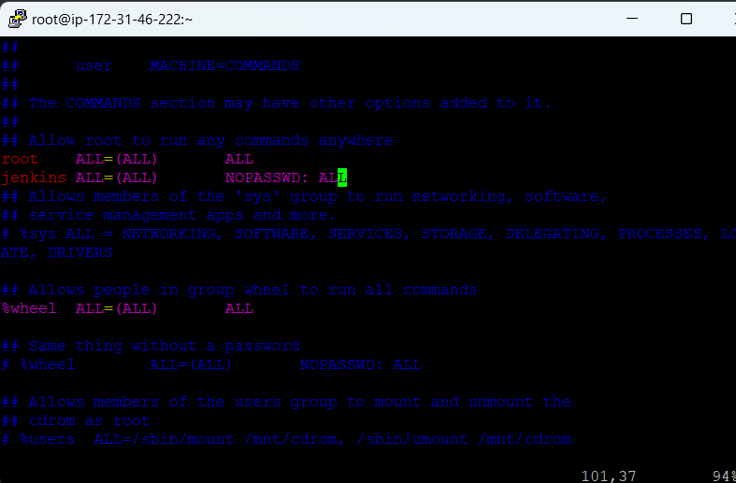

STEP 7 - #update the login shell of jenkins user from /bin/nologin to /bin/bash

grep jenkins /etc/passwd

jenkins:x:995:993:Jenkins Automation Server:/var/lib/jenkins:/bin/bash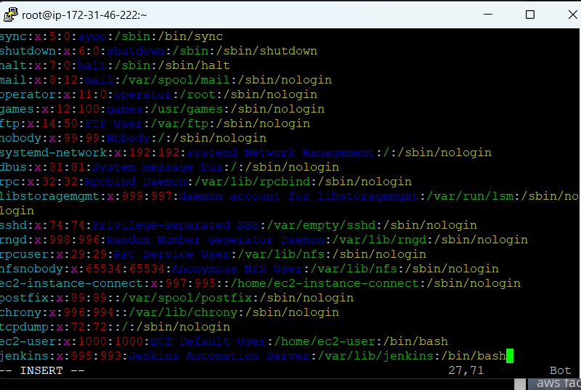

STEP 8 - #login as jenkins user

create root user access key and secrect access key

aws configure --profile aws-root-credentials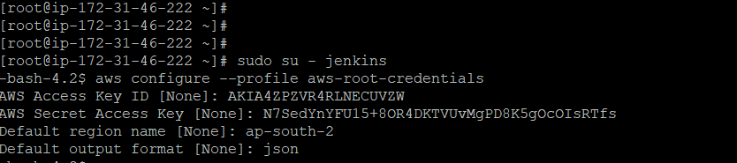



STEP 9 - now create all the required credentials in Jenkins 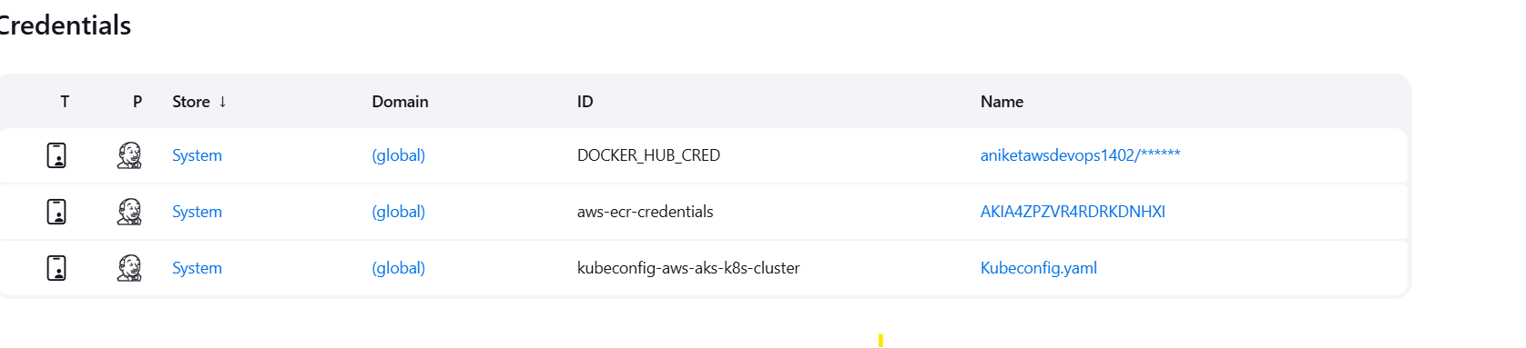

STEP 10 - And to connect the eks cluster we have to create a secret file credentials and in that we have to provide The kubconfig file (copy the content and save as yaml file ) and attach it and for this kubconfig file you have to connect to the cluster by using this command - connect to k8s cluster

aws eks --region ap-south-2 update-kubeconfig --name aws-k8s-cluster --profile aws-root-credentials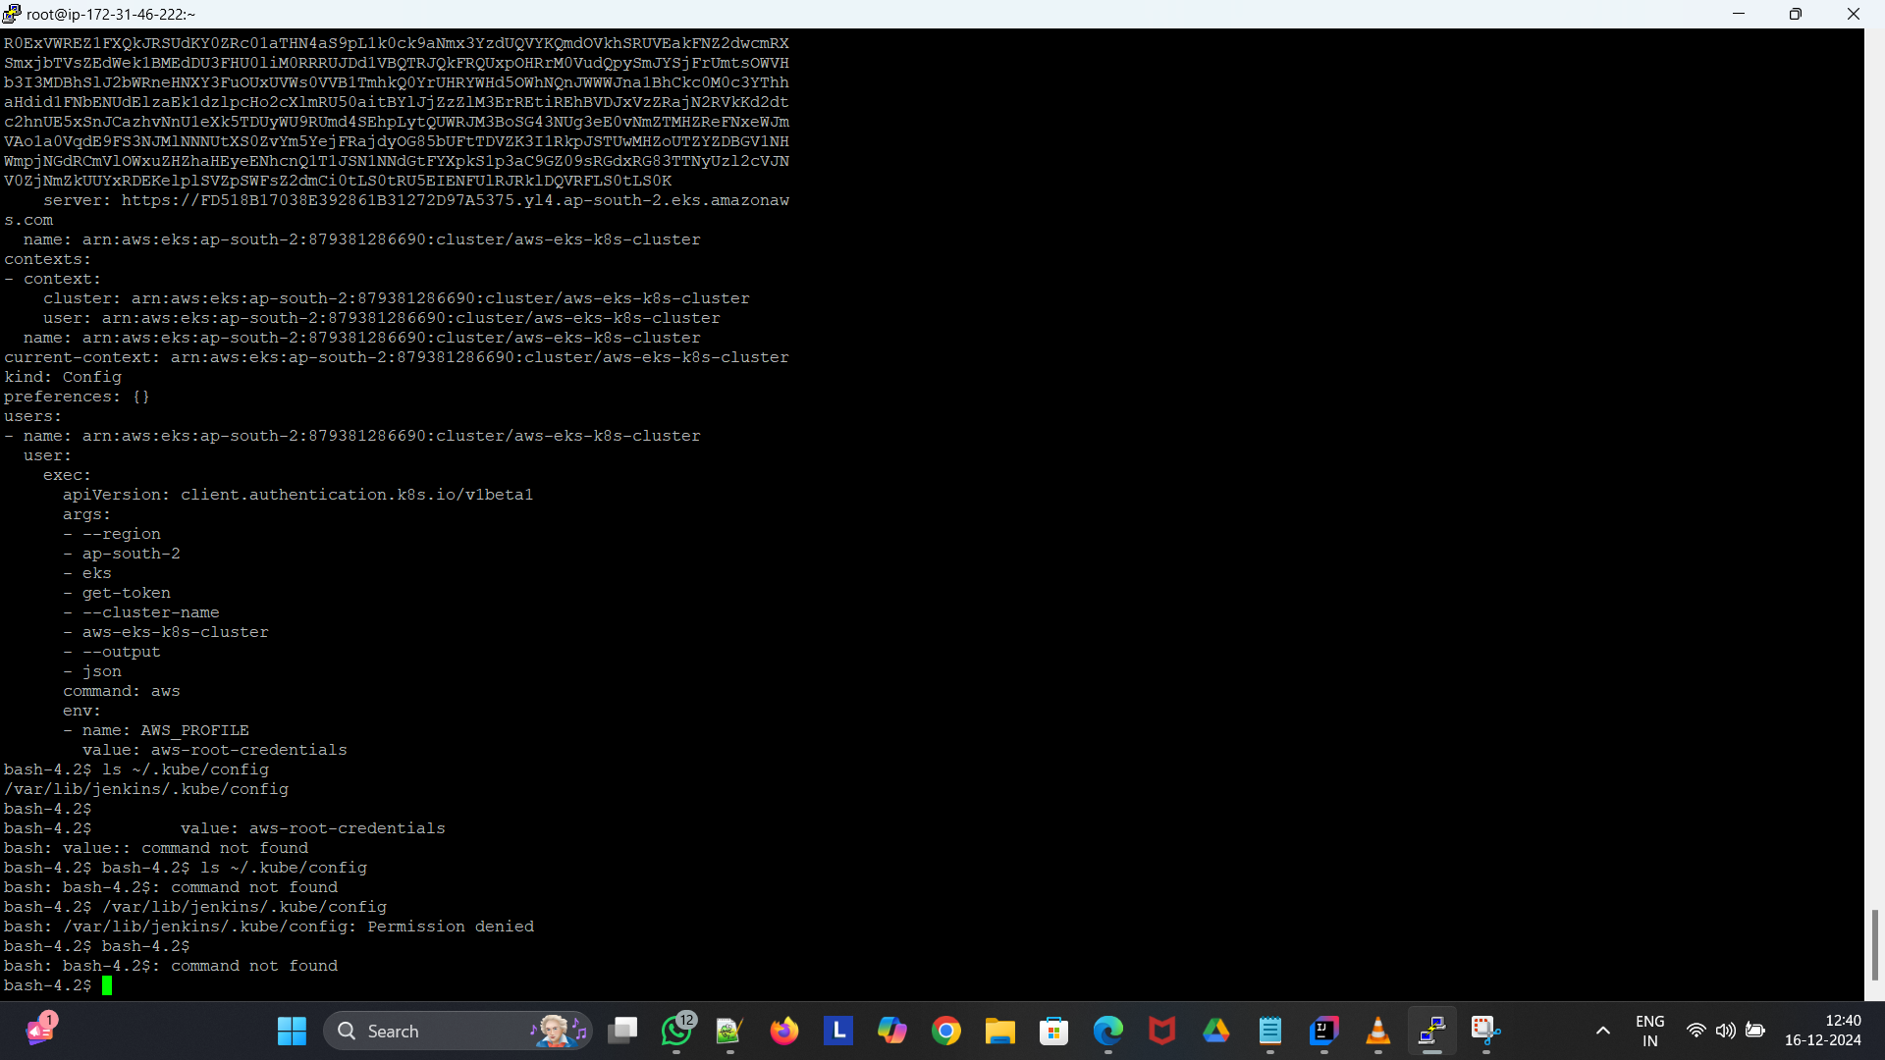

STEP 11 - now configure all the tools versions and path (maven , git , java )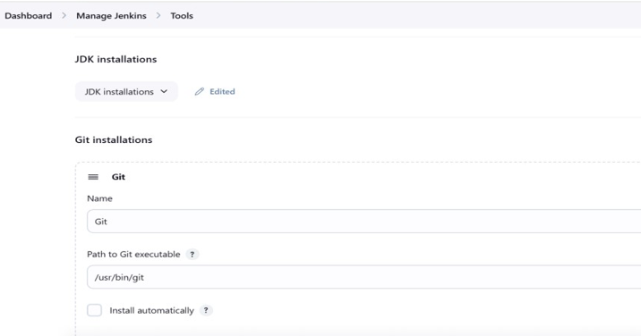

STEP 12 - create a repository in amazon ecr to store the docker images that we are going to create by our pipeline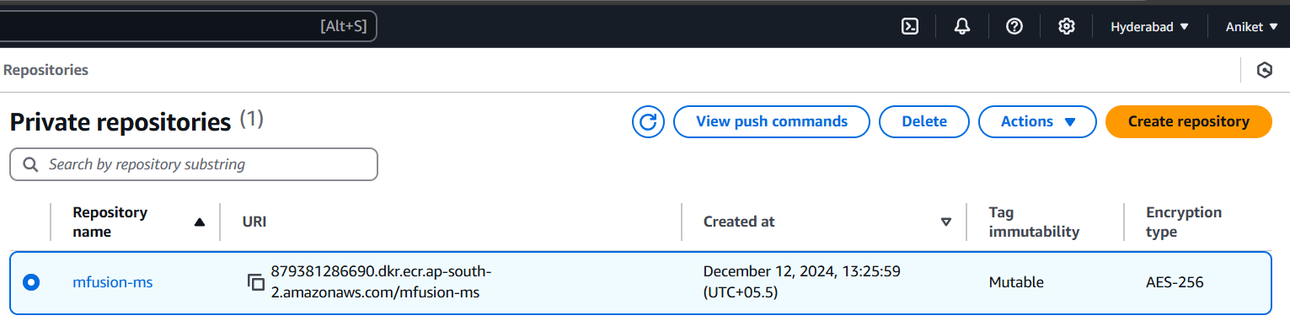

STEP 13 - Now Jenkins is fully setup for running the Multibranch pipeline and connected the eks cluster 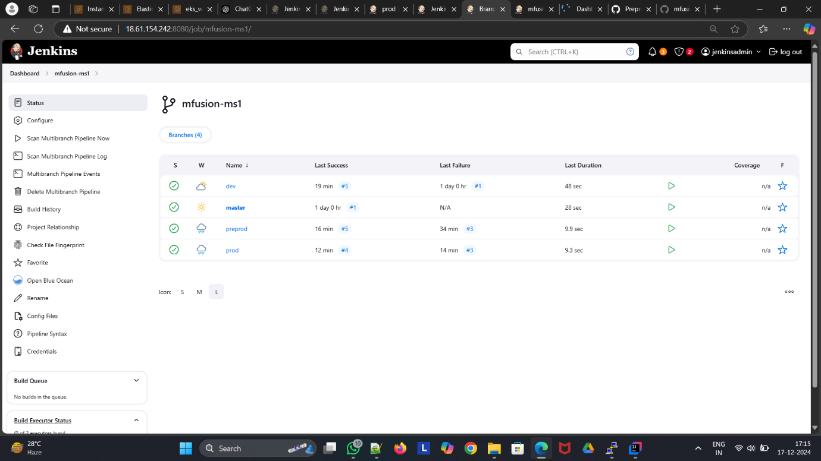

STEP 14 - Now as we push aur code into dev branch the webhook triggers jenkins it will only run the stages that we have mention in our Jenkins file in dev branch it will Create a image

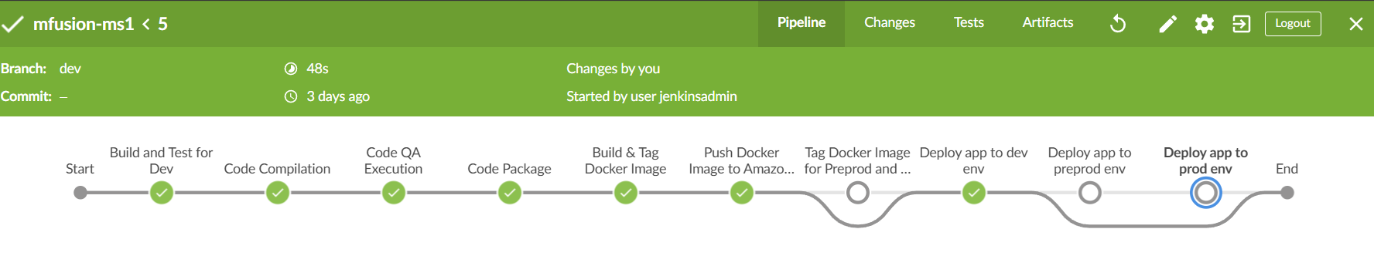

STEP 15 - Now we have to create a pullrequest from dev to preprod and then it will run the preprod(stage/branch) it will use that image that we have created by the dev branch 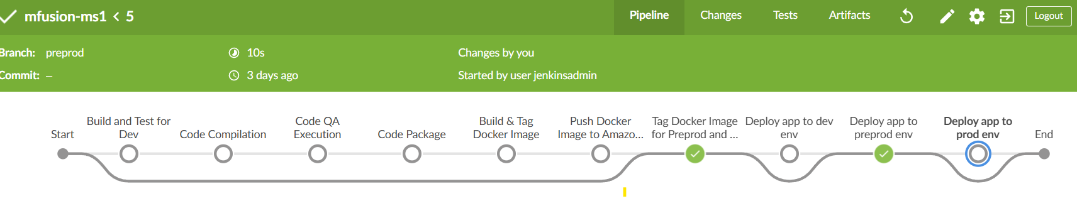

STEP 16 - Now we have to create a pull request from preprod to prod and it will run prod (stage/branch) it will use the image that created by the preprod branch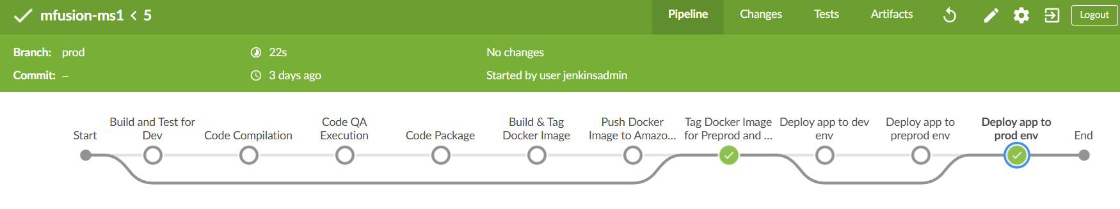

**Thankyou**